Assignment Requirements
1. Reproduce the Labs
Re-run all the Nmap scans demonstrated in class (host discovery, port scanning, service detection, OS fingerprinting, basic scripting, etc.).
Recreate all the Scapy exercises (packet crafting, sending, sniffing, and basic protocol analysis).
2. Document Your Work on GitHub
Create a new repository or update your existing cybersecurity repo.
Include:
A clear README.md explaining the objectives, setup, and results.
Well-structured screenshots where necessary.
Code snippets or commands used.
Brief explanations of what each scan or script accomplishes.
Ensure your repo looks clean, organized, and professional.
3. Publish a Short Reflection Post
Write a short, educational post on LinkedIn or Medium summarizing:
What you learned.
What was challenging.
How these tools matter in real-world cybersecurity work.
Keep it concise and professional, your post is part of your public cybersecurity footprint.

Objectives
Nmap is a powerful open-source tool for network mapping and discovery. In this lab, you will use Nmap as part of your active reconnaissance strategy.
- Investigate Nmap
- Perform Basic Nmap Scans
Background / Scenario
A Wireshark capture shows unusual activity on a machine on the 10.6.6.0 DMZ network. You’ve been asked to do some active recon on the machine to determine what services it may be offering and if there are vulnerable applications that could present security issues. The IP address of the suspicious computer is 10.6.6.23. You have access to a Kali Linux system on the 10.6.6.0 network.
Required Resources
- Kali VM customized for Ethical Hacker course
Instructions
Part 1: Investigate Nmap
Step 1: Log into Kali Linux and verify the environment.
- Log into the Kali system with the username kali and the password kali. You are presented with the Kali desktop.
- Open a terminal window.
- Verify that Kali has an interface in the 10.6.6.0/24 network using the ifconfig command.
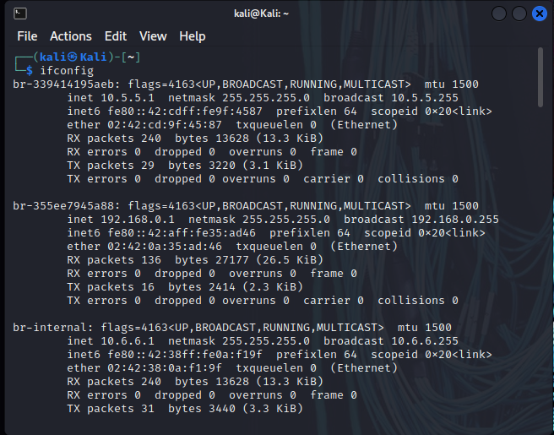
- Use the nmap -V command to verify that Nmap is installed and to display the Nmap version.
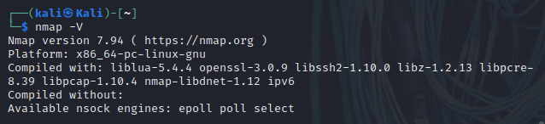
Step 2: Investigate Nmap Options and Features
- Using the command nmap without specifying any options or targets returns a list of commonly used Nmap options. To access the Nmap help system use the command nmap -h. The help output is divided into sections based on the type of detection that the option supports.
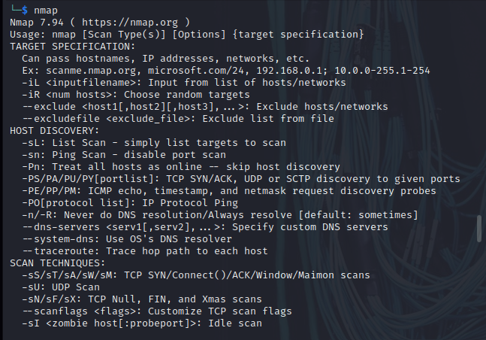
- The man page for Nmap provides additional information. To access the man page, enter the command man nmap. To exit the man pages, press q to quit and return to the terminal prompt.
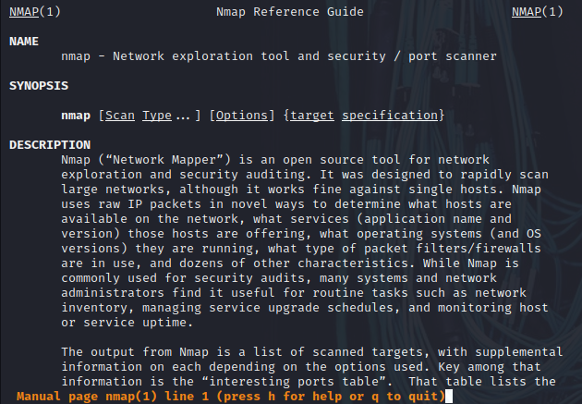
Option | Description
-A | Aggressive scan that enables OS detection, version detection, script scanning and traceroute
-O | Enables OS detection
-p <port ranges> | Allow specific ports or port ranges to be scanned
-sF | Performs TCP FIN scan
-sn | Performs host discovery scan
-sS | Performs TCP SYN scan
-sT | Performs TCP Connect scan
-sV | Probes open ports to determine service/version info
-T<0-5> | Sets the timing of the scan.
-v | Increses the verbosity of the output
--open | Only reports open ports

Part 2: Perform Basic Nmap Scans
Step 1: Initiate a basic Nmap scan of the target computer.
- To quickly scan the DMZ for active hosts, you can perform a discovery scan. In a discovery scan, the scanning host sends an ICMP echo request (ping), a TCP SYN to port 443, a TCP ACK to port 80, and an ICMP timestamp request. A response to any of the requests indicates that the host is up and the IP protocol stack on the host is functioning. Enter the following command to scan the DMZ network:
$ nmap -sn 10.6.6.0/24
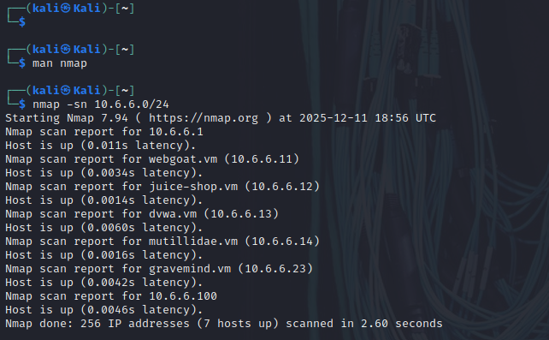
There are 7 hosts up.

- The host 10.6.6.23 was identified as suspicious in a Wireshark capture, and it is necessary to perform additional reconnaissance to discover more about the computer and its services. Use the nmap command to execute a default scan on the target host.
$ nmap 10.6.6.23
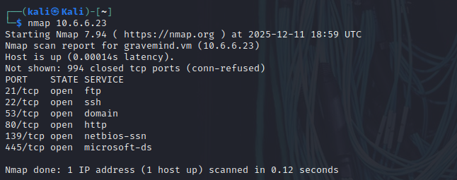
The listed open ports are: 21, 22, 53, 80, 139, and 445.
By default, Nmap performs a connect scan of 1000 most common TCP ports. This makes use of the operating system’s networking software to establish a full TCP connection. This type of scan creates a lot of networking traffic and increases the probability of detection by intrusion detection services. You can also specify a TCP connect scan using the command option nmap -sT.
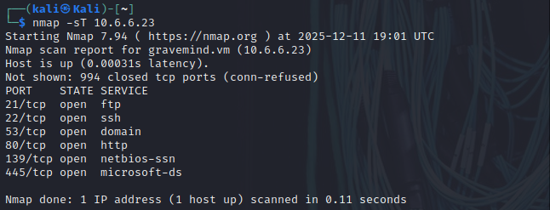
The output of the connect scan includes the status codes shown in the table:
Status | Response Received | Interpretation
Open | TCP SYN-ACK | There is a service listening on the identified port
Closed | TCP RST | There is no service listening on the identified port
Filtered | No response, or an ICMP destination unreachable message received | The port is being filtered by the firewall.

- The -O option can be used to further determine information about the operating system running on the target host. Some Nmap options require additional permissions and must be run as root or using the sudo command. To find operating system information on the target host, use the nmap -O command. Enter the password of kali when prompted.
$ sudo nmap -O 10.6.6.23
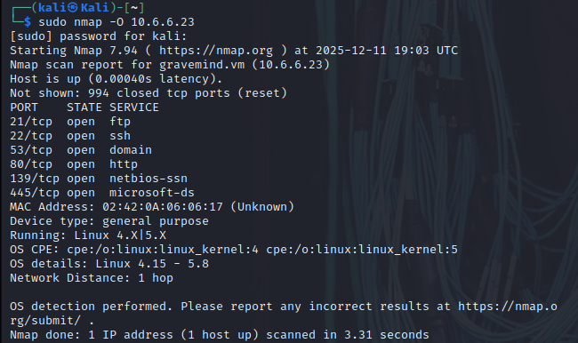
The operating system on the host is Linux 4.15 – 5.8
Step 2: Obtain additional information about the host and services.
- To provide additional information about the target computer, it is possible to combine different options into a single command line. The previous command identified several potentially open ports on the 10.6.6.23 host. You can use -v, -p, and -sV to find additional information about the services running on the open ports. This command provides information about the FTP service running on port 21 on the target in verbose mode, with the timing set to fast (-T4):
$ nmap -v -p21 -sV -T4 10.6.6.23
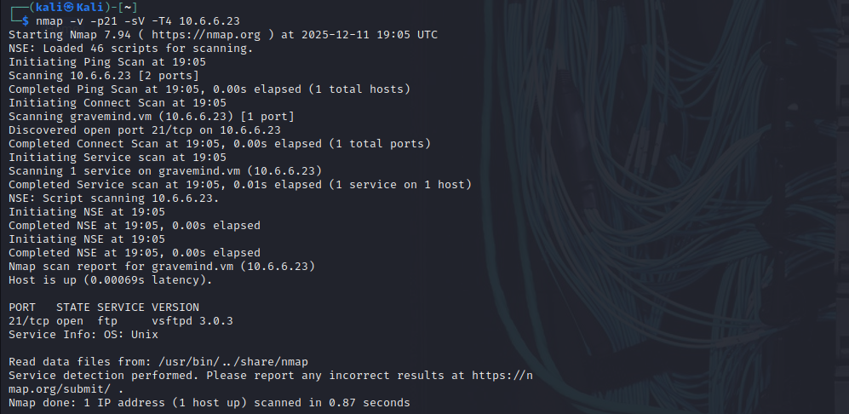
The command lists the version of FTP running on the computer as vsftpd 3.0.3.

- The -A option executes OS detection, version detection, script scanning, and traceroute. The -A scan can be very intrusive and therefore will be detected by many IDS systems, so ensure that you have permission before attempting this scan outside of the lab environment. To gather more information regarding the FTP service, enter the command nmap -p21 -sV -A 10.6.6.23.
The sample detailed output of this command is shown below:
$ nmap -p21 -sV -A 10.6.6.23
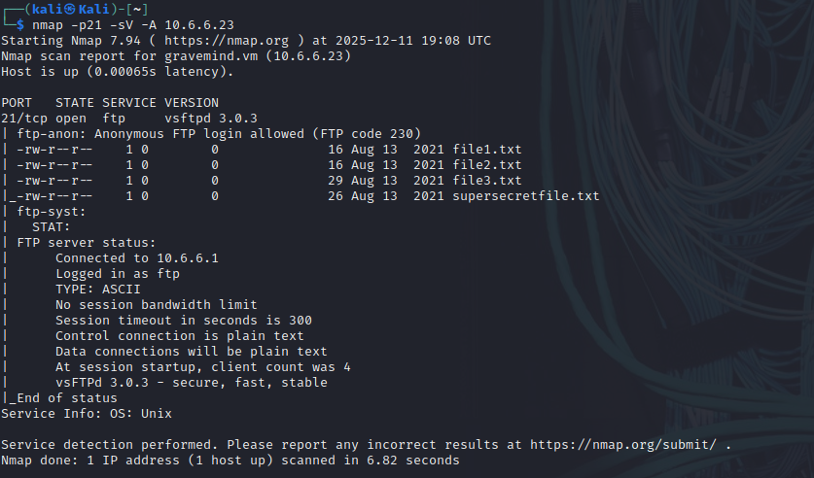
Step 3: Investigate SMB Services with Scripts
The Server Message Block (SMB) protocol is a network file sharing protocol supported on Windows computers and by SAMBA on Linux. SMB enables applications to read and write files or request services over a network. Open public shares or shared devices such as print servers on a network, can be accessed through SMB.
- The earlier scan of open ports on the target computer indicates that the SMB ports 139 and 445 are open. Find more information on these ports using the -A and -p command options. The -A option executes several functions including running the default scripts. Specify more than one port to scan by listing them separately with a comma between them.
$ nmap -A -p139,445 10.6.6.23
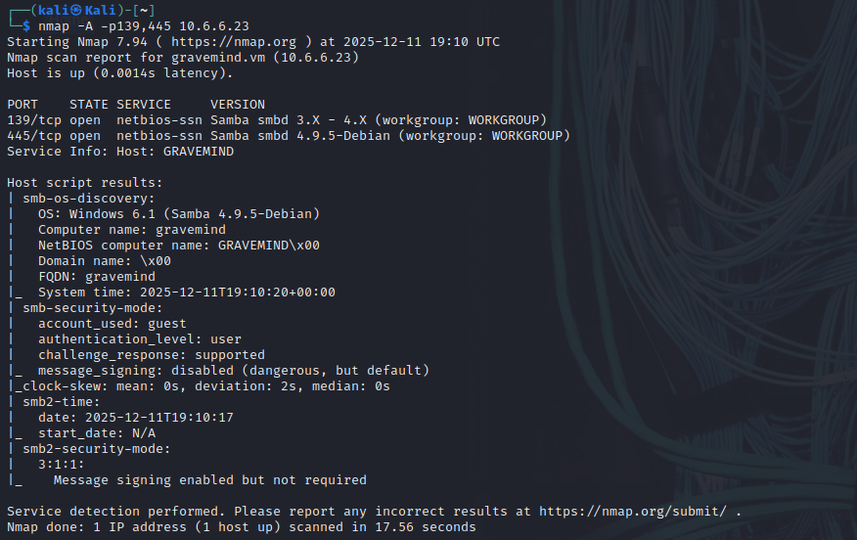
- Nmap contains the powerful Nmap Scripting Engine (NSE), which enables the programming of various Nmap options and conditional actions to be taken as a result of the responses. NSE has built-in scripts that enumerate users, groups, and network shares. One of the more commonly used scripts for SMB discovery is the smb-enum-users.nse script. Use the Nmap NSE script with the command:
$ nmap --script smb-enum-users.nse -p139,445 10.6.6.23
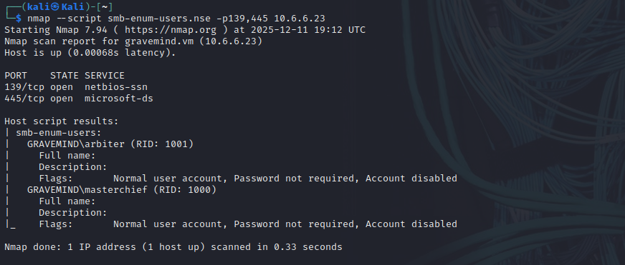
Two usernames, arbiter and masterchief.

- A serious security concern is the existence of publicly shared directories (folders). You can enumerate the network shares using another NSE script, smb-enum-shares.nse. To discover shared directories on the target computer. Use the Nmap share enumeration script with the command:
$ nmap --script smb-enum-shares.nse -p445 10.6.6.23
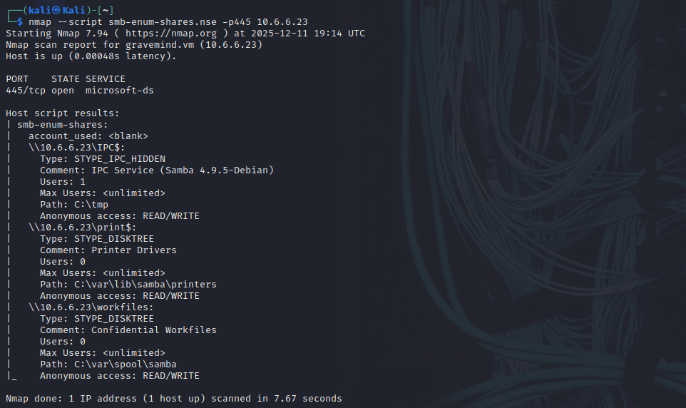
- Examine the output created by the smb-enum-shares script. In the output, share names that end with a “$” character represent hidden shares that include system and administrative shares.
\\10.6.6.23\IPC$, \\10.6.6.23\print$,
Lab - Packet Crafting with Scapy
Scapy lets you create and send packets that have the values that you want in the protocol data fields. For example, you can craft packets that have manipulated source and destination IP addresses, TCP flags and port numbers, and many other values that you specify.
In this lab, you will use Scapy, a Python-based packet manipulation tool, to craft custom packets. These custom packets will be used to perform reconnaissance on a target system.
Objectives:
- Part 1: Investigate the Scapy Tool.
- Part 2: Use Scapy to Sniff Network Traffic.
- Part 3: Create and Send an ICMP Packet.
- Part 4: Create and Send TCP SYN Packets.
Background / Scenario
Penetration testers and ethical hackers often use specially-crafted packets to discover and/or exploit vulnerabilities in clients’ infrastructure and systems. You have used Nmap to scan and analyze vulnerabilities in a computer attached to the local network.
This lab will perform further reconnaissance on the same computer using custom ICMP and TCP packets.
Instructions
Part 1: Investigate the Scapy Tool
Step 1: Investigate Scapy documentation and resources.
- Start the Kali VM and login.
- Open the Firefox browser and navigate to https://scapy.readthedocs.io/en/latest/introduction.html. Read the Introduction page written by the Scapy creator, Philippe Biondi.
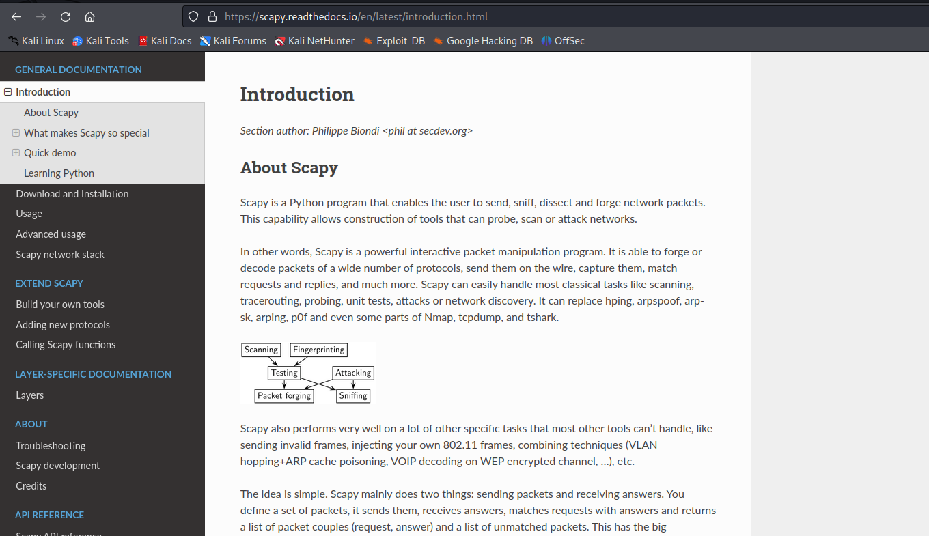
Scapy is a Python program that enables the user to send, sniff, dissect and forge network packets. This capability allows construction of tools that can probe, scan or attack networks.
In other words, Scapy is a powerful interactive packet manipulation program. It is able to forge or decode packets of a wide number of protocols, send them on the wire, capture them, match requests and replies, and much more. Scapy can easily handle most classical tasks like scanning, tracerouting, probing, unit tests, attacks or network discovery. It can replace hping, arpspoof, arp-sk, arping, p0f and even some parts of Nmap, tcpdump, and tshark.
Step 2: Use Scapy interactive command mode.
Enter the scapy command in a terminal window to load the Python interpreter.
- The commands to craft and send packets require root privileges to run. Use the sudo su command to obtain root privileges before starting Scapy. If prompted for a password, enter kali.
$ sudo su
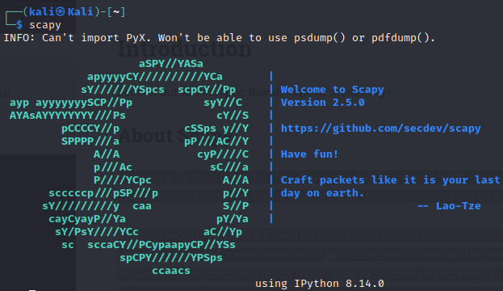

$ sudo su

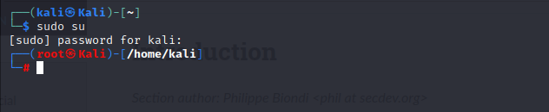
- At the >>> prompt within the Scapy shell, enter the ls() function to list all of the available default formats and protocols included with the tool. The list is quite extensive and will fill multiple screens.
>>> ls()
TFTP is a protocol used to send and receive files on a LAN segment. It is commonly used to back up configuration files on networking devices. Scroll up to view the available TFTP packet formats.
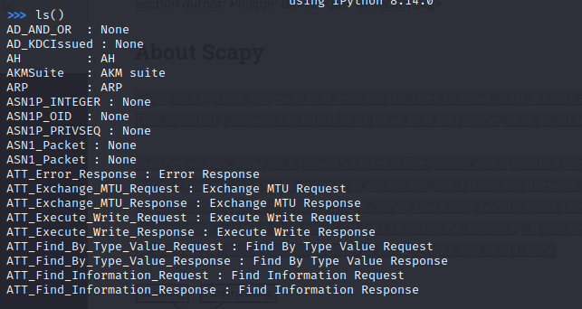

There are 9 TFTP packet formats are listed
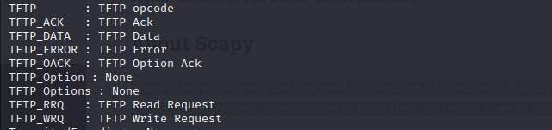
Step 3: Examine the fields in an IPv4 packet header.
- It is important to understand the structure of an IP packet before creating and sending custom packets over the network. Each IP packet has an associated header that provides information about the structure of the packet. Review this information before continuing with the lab.
IPv4 Packet Header Fields
The binary values of each field identify various settings of the IP packet. Protocol header diagrams, which are read left to right, and top down, provide a visual to refer to when discussing protocol fields. The IP protocol header diagram in the figure identifies the fields of an IPv4 packet.
- The ls() function can also be used to list details of the fields and options available in each protocol header. The syntax to use a function in Scapy is function_name(arguments). Use the ls(IP) function to list the available fields in an IP packet header.
>>> ls(IP)
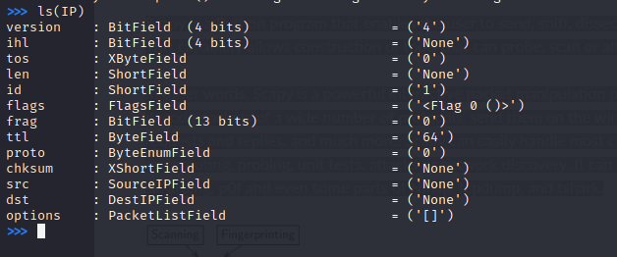
Part 2: Use Scapy to Sniff Network Traffic
Scapy can be used to capture and display network traffic, similar to a tcpdump or tshark packet collection.
Step 1: Use the sniff() function.
- Use the sniff() function to collect traffic using the default eth0 interface of your VM. Start the capture with the sniff() function without specifying any arguments.
>>> sniff()
- Open a second terminal window and ping an internet address, such as www.cisco.com. Remember to specify the count using the -c argument.
$ ping -c 5 www.cisco.com
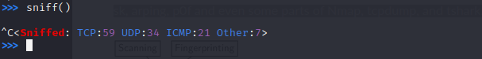
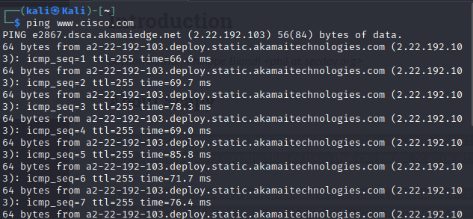
- Return to the terminal window that is running the Scapy tool. Press CTRL-C to stop the capture.
- View the captured traffic using the summary() function. The a=_ assigns the variable a to hold the output of the sniff() function. The underscore ( _ ) in Python is used to temporarily hold the output of the last function executed.
>>> a=_
>>> a.summary()
The output of this command can be extensive, depending on the applications running on the network.
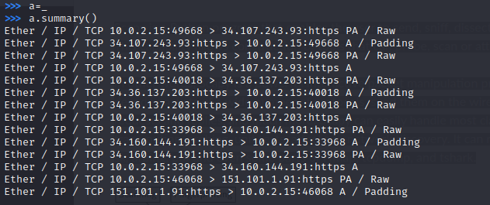
Step 2: Capture and save traffic on a specific interface.
In this step, you will capture traffic to and from a device connected to a virtual network in your Kali Linux VM.
- Open a new terminal window. Use the ifconfig command to determine the name of the interface that is assigned the IP address 10.6.6.1. This is the default gateway address for one of the virtual networks running inside Kali. Note the name of interface.
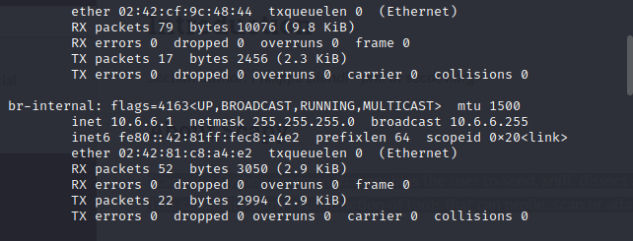
- Return to the terminal window that is running the Scapy tool. Use the syntax sniff(iface="interface name") to begin the capture on the br-internal virtual interface.
>>> sniff(iface="br-internal")
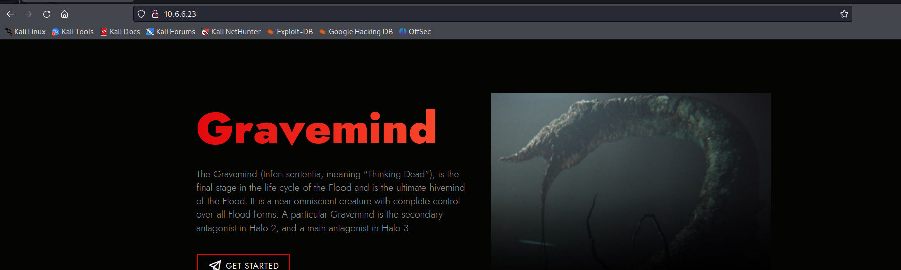
- View the captured traffic as you did in Step 1d.
>>> a=_
>>> a.summary()
Step 3: Examine the collected packets.
In this step, you will filter the collected traffic to include only ICMP traffic, limit the number of packets being collected, and view the individual packet details.
- Use interface ID associated with 10.6.6.1 (br-internal) to capture ten ICMP packets sent and received on the internal virtual network. The syntax is sniff(iface="interface name", filter = “protocol", count = integer).
>>> sniff(iface="br-internal",filter = “icmp",count = 10)
- Open a second terminal window and ping the host at 10.6.6.23.
$ ping –c 10 10.6.6.23
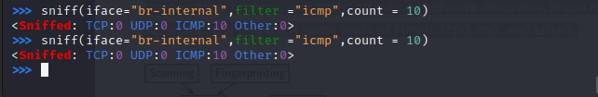
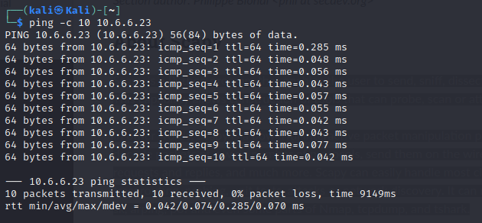
- Return to the terminal window running the Scapy tool. The capture automatically stopped when 10 packets were sent or received. View the captured traffic with line numbers using the nsummary() function.
>>> a=_
>>> a.nsummary()
The summary should only contain 10 lines because the capture count is equal to 10.
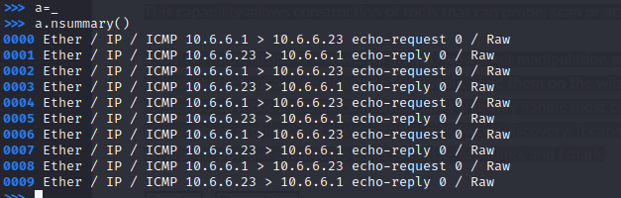
- Use the wrpcap() function to save the captured data to a pcap file that can be opened by Wireshark and other applications. The syntax is wrpcap(“filename.pcap", variable name), in this example the variable that you stored the output is “a".
>>> wrpcap(“capture1.pcap", a)
- The .pcap file will be written to the default user directory. Use a different terminal window to verify the location of the capture1.pcap file using the Linux ls command.
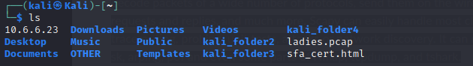

- Open the capture in Wireshark to view the file contents.
Part 3: Create and Send an ICMP Packet.
ICMP is a protocol designed to send control messages between network devices for various purposes. There are many types of ICMP packets, with echo-request and echo-reply the most familiar to IT technicians. To see a list of the message types that can be sent and received using ICMP, navigate to https://www.iana.org/assignments/icmp-parameters/icmp-parameters.xhtml
Step 1: Use interactive mode to create and send a custom ICMP packet.
- In a Scapy terminal window, enter the command to sniff traffic from the interface connected to the 10.6.6.0/24 network.
>>> sniff(iface="br-internal")
- Open another terminal window, enter sudo su to perform packet crafting as root. Start a second instance of Scapy. Enter the send() function to send a packet to 10.6.6.23 with a modified ICMP payload.
$ sudo su
# scapy

>>> send(IP(dst="10.6.6.23")/ICMP()/"This is a test")
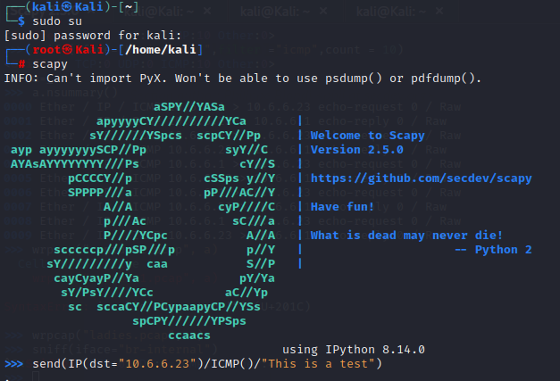
- Return to the first terminal window and press CTRL-C. You should receive a response similar to this:
^C<Sniffed: TCP:0 UDP:0 ICMP:2 Other:0>
- Enter the summary command to display the summary with packet numbers.
>>> a=_
>>> a.nsummary()
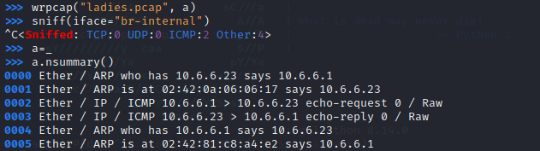
Part 4: Create and Send a TCP SYN Packet.
In this part, you will use Scapy to determine if port 445, a Microsoft Windows drive share port, is open on the target system at 10.6.6.23.
Step 1: Start the packet capture on the internal interface.
- In the original Scapy terminal window, begin a packet capture on the internal interface attached to the 10.6.6.0/24 network. Use the interface name that you obtained previously.
- Navigate to the second terminal window. Create and send a TCP SYN packet using the command shown.
>>> send(IP(dst="10.6.6.23")/TCP(dport=445, flags="S"))
1 packet sent
This command sent an IP packet to the host with IP address 10.6.6.23. The packet is addressed to TCP port 445 and has the S (SYN) flag set.

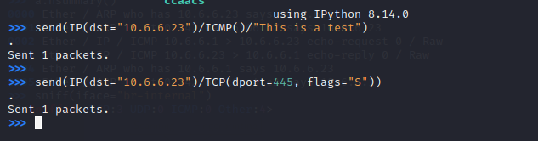
Step 2: Review the captured packets.
- In the original Scapy terminal window, stop the packet capture by pressing CTRL-C. The output should be similar to that shown.
^C<Sniffed: TCP:3 UDP:0 ICMP:0 Other:0>
- View the captured TCP packets using the nsummary() function. Display the detail of the TCP packet that was returned from the target computer at 10.6.6.23.
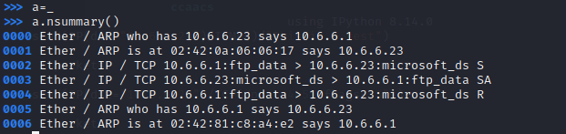
>>> a[packet number]

